Technical Specification

Customer Name : Pars Appliance MFG. CO.

Model Name : 1700 No Frost
Twin Frz

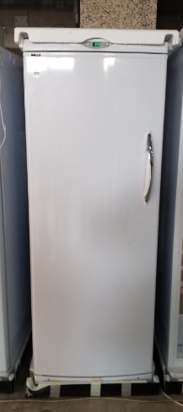

February 11, 2020

Program : PARS_TWIN_FRZ_(1700_No_Frost)_MAIN(20200211.hex

Keys & Function

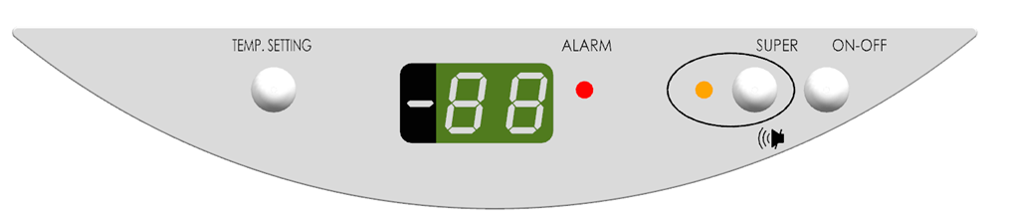

- TEMP.SETTING Setting the Ref Room Temperature (-16℃ ~ -24℃)

- SUPER (Mute) Canceling the Buzzer Sound

- SUPER (3 seconds) Setting the “Super Freeze Mode”

- ON/OFF Power ON/OFF during the Plug-In states
Note>
During the OFF Mode, all Function should be not workable.
(including not checking the Error)

Cf> Dual Keys

- Manual Defrost Mode (Hr) “SUPER + ON/OFF” (5 seconds)

- Test Mode “TEMP.SETTING + SUPER” (5 seconds)

- States Mode (St) “TEMP.SETTING + SUPER + ON/OFF” (5 seconds)

Indicating LED Lamp

- “ALARM” LED Lamp indicating the abnormal working state as like Door Open / Error
Red Color
Blanking ON / OFF
Note>
If the Door is opened for over 60 seconds, the Buzzer Sound becomes activated. (ON 0.5 seconds / OFF 0.5 seconds)

- “SUPER” LED Lamp Indicating the “Super Freeze Mode” activating
Yellow Color
ON / OFF

Displaying Temperature

- “-88” Segments indicating the Setting Temperature / Error Code / States Code

Remarks>
During the Cooling mode, the Setting Temperature is displayed after reaching to -9℃.
The Blinking can be canceled by pushing the Mute key.

Cooling Mode / Setting the Temperature

1. Plug-In & Entering the Cooling Mode

Under the “ON” Setting,
the Refrigerator (Twin Frz : 1700 No Frost) is working in accordance with below Cut-In / Cut-Off.

Setting Temp. | Cut-In (Comp ON) Temp  by Room Sensor | Cut-Off (Comp Off) Temp  by Room Sensor
-16 ℃ | -14 ℃ | -17℃
-17 ℃ | -15 ℃ | -18 ℃
-18 ℃ | -16 ℃ | -19 ℃
-19 ℃ | -17 ℃ | -20 ℃
-20 ℃ | -18 ℃ | -21 ℃
-21 ℃ | -19 ℃ | -22 ℃
-22 ℃ | -20 ℃ | -23 ℃
-23 ℃ | -21 ℃ | -24 ℃
-24 ℃ | -22 ℃ | -25 ℃

2, Displaying the Temperature and Setting the Temperature during the Cooling Mode

- Default Temp : -20 ℃

- How to set the Temperature
- Pushing the “Temp” key for 2 seconds, Blinking in Temp Setting during during Temp Setting.
- -20 ℃ -→ -21 ℃ -→ -22 ℃ -→ -23 ℃ -→ -24 ℃ -→ -16 ℃ -→ -17 ℃ -→ ….-→ -20 ℃

- During the Cooling Mode, the Setting Temperature is displayed on the Display Panel.

Note> In “over -9℃ since Plug-in”, the Real Temperature is displayed with blinking.
The Blinking can be canceled by pushing the Mute key.

Remarks> The latest Setting Temperature is saved even in plug-out.

3, Room LED / Alarm in Door Open

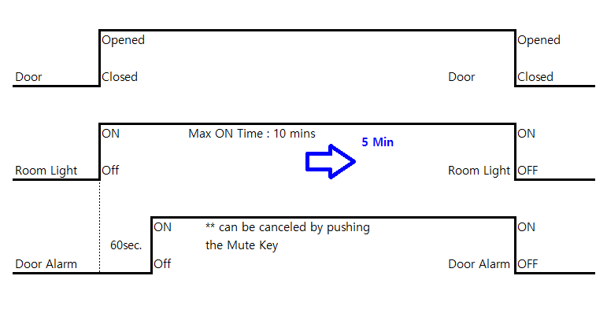

- Room LED ON Max : 5 minutes

- Door Alarm is kept blanking if the Door is continuously opened since 60 seconds later.

- Buzzer Sound becomes ON (ON 0.5 seconds ←-→ OFF 0.5 seconds) with the Door Alarm ON. And it can be canceled by pushing the Mute key. But the canceled Buzzer Sound becomes again ON if the Door is continuously opened. And it will not become again ON until the Door is opened. But Mute Alarm will reset when the Door is Closed

Super Freeze Mode

How to enter / terminate

Pushing the Super key for 3 seconds

Operating the Super Cooling Mode

- Continuously Comp ON & Fan ON 24 Hours until reaching to -31℃

- Yellow LED ON
& Displaying “SU” in Super Freeze Mode (not displaying the Temp)

- Once automatically finishing the Super Freeze Mode (in 24 Hrs / -31℃)
the Auto Defrost Mode will be automatically started.

.

Defrost Mode

1> Auto Defrost

- Defrost Cycle Time
- Total Comp ON 30 Hours (not opening the Door)
- Total Comp ON 12 Hours (Door Open 1 ~ 3 times)
- Total Comp ON 8 Hours (Door Open over 3 times)

- Heater ON Time (Maximum) : 30 minutes

- Heater ON Time (Minimum) : 1 minute

- Heater OFF Temperature (after passing 1 minute) : +10℃

Note>
In Defrost Sesonr Error, Heater ON Time is 15 minutes. ---→ In Defrost Sensor Error, NO Defrost

- Water Drain Time (after Heater OFF) : 10 minutes (Comp On / Fan ON Delay)

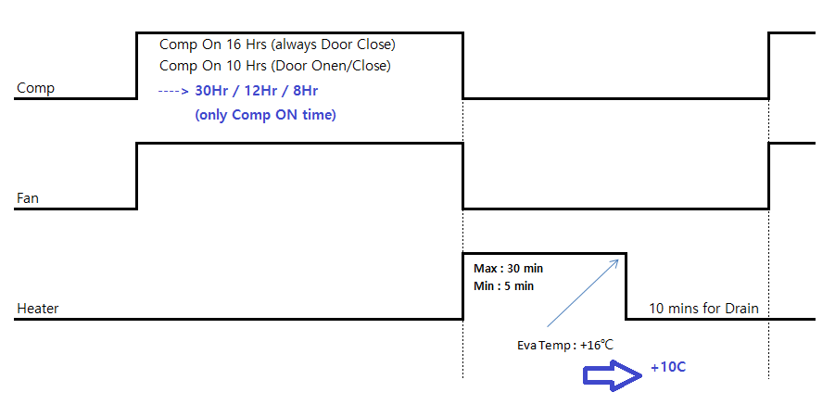

Note> During the Auto Defrost Mode, the Setting Temperature is displayed.

2> Manual Defrost

- How to enter : “Super + ON/OFF” for 5 seconds

*** defrost first when the refrigerator is plug on even if the EVA temp is warmer than +10℃

- Heater ON Time (Maximum) : 30 minutes

- Heater ON Time (Minimum) : 1 minute

- Heater OFF Temperature (after passing 1 minute) : +10℃

- Water Drain Time (after Heater OFF) : 10 minutes (Comp On / Fan ON Delay)

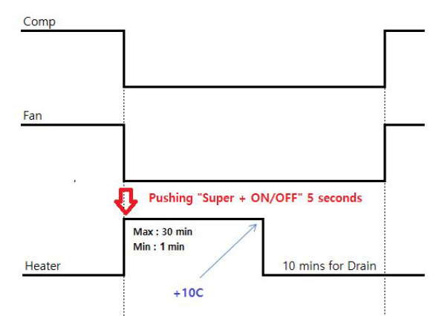

Note> During the Manual Defrost Mode, “Hr” is displayed.

Note> In Defrost Sensor Erro, NO Defrost

*** Heater OFF Temperature (after passing 1 to 30 minute or +10 ℃ ) heater OFF but (Hr) is displayed in the display

Error Mode

1. Room Sensor Error : Error Code “FF”
- Room Sensor “Open / Short” condition
- Displaying Error code : FF
- Alarm ON with Buzzer Sound ON (ON 1 second ←-→ OFF 1 second)
But Buzzer Sound can be OFF by Pushing the Mute key.
And it will not become again ON until the Door is opened.
- Comp ON 30 minutes <---> Comp OFF 30 minutes
*** Comp ON 40 minutes <---> Comp OFF 20 minutes
2. Defrost Sensor Error : Error Code “dF”
- Defrost Sensor “Open / Short” condition
- Displaying Error code : dF
- Alarm ON with Buzzer Sound ON (ON 1 second ←-→ OFF 1 second)
But Buzzer Sound can be OFF by Pushing the Mute key.
And it will not become again ON until the Door is opened.
- NO Defrost

3. Cooling Error : Error Code “LO”
- Room Temperature is continuously “over -9℃ (as like -8℃) for 10 hours”.
- Displaying Error code : LO
- Alarm ON with Buzzer Sound ON (ON 1 second ←-→ OFF 1 second)
But Buzzer Sound can be OFF by Pushing the Mute key.
And it will not become again ON until the Door is opened.

4. Defrost Error : Error Code “HE”
- Even though passing the Heater ON Max Time (30 minutes), the Defrost Sensor Temp is not reached to +10℃

Test Mode

How to enter

Pushing the “Temp + Super” keys for 5 seconds

Auto Test Mode
automatically starting to Test the parts (Comp / Fan / Heater / Room Lamp) as below.

- Turning ON 88-Segments for each 1 second interval
- Turning ON LED (RED LED / YELLOW LED) for each 1 second interval
- 5 seconds Delay Time for checking the 3 keys
- Comp ON for 5 seconds
- Heater ON for 5 seconds
- Room Lamp ON for 5 seconds

And then,
Automatically returning to the Normal Cooling Mode

States Mode

How to enter

Pushing the “Temp + Super + ON/OFF” keys for 5 seconds
Displaying the “St” in States Mode,
pushing “Temp” key

Displaying the States in sequence

tA (Room Temperature)
Temp
tE (Eva Temperature)
Temp
CO (Compressor)
ON / -- (OFF)
Hr (Heater)
ON / -- (OFF)

How to terminate

Pushing the “Temp + Super + ON/OFF” keys
Or
If no key is pressed after 2 minutes, automatically returning to the Normal Cooling Mode.
*** State mode in condition Manual Defrost Not displayed

